Assignment- 3

|  |  |
| --- | --- |
| Student name | SIVARAMAKRISHNAN M |
| Roll no/Reg no | 411419104023 |
| College Name | New Prince Shri Bhavani Clg Of Engg & Tech |
| Assesment No | 03 |

# ****Tasks****

## ****1.Downloading and unzipping dataset****

Solution:

!unzip '/content/drive/MyDrive/flower dataset'

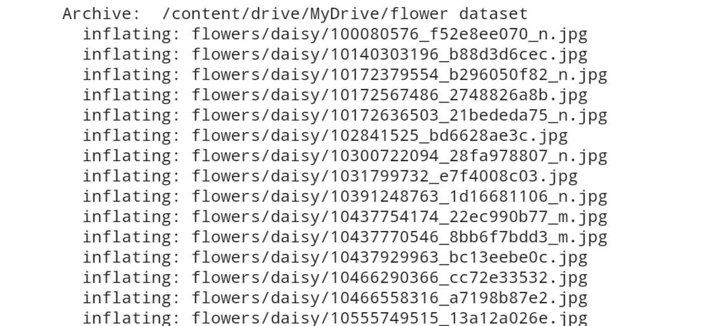

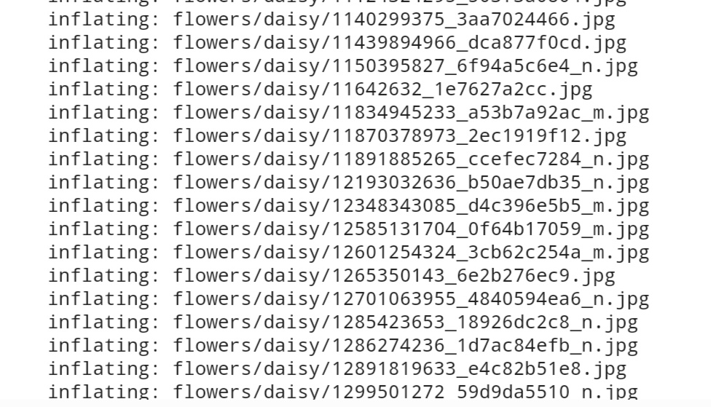

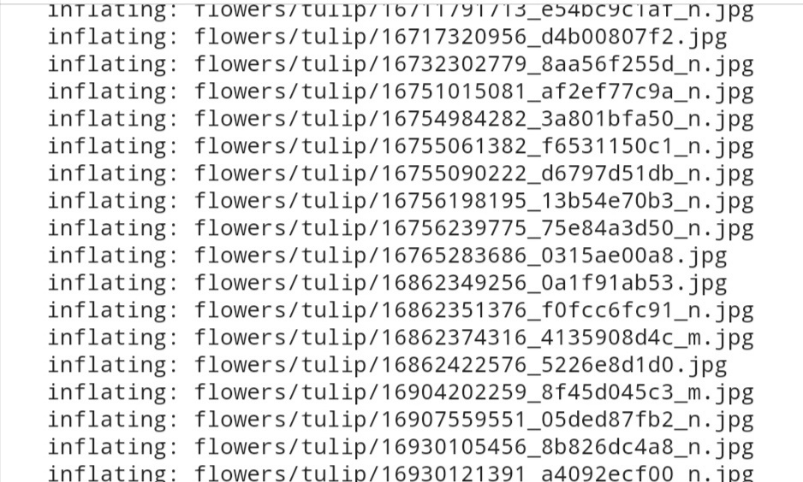



## ****2. Image Augmentation****

Solution:

**import** numpy **as** np

**import** tensorflow **as** tf

**from** tensorflow.keras **import** layers

**from** tensorflow.keras.models **import** Sequential

**from** tensorflow.keras.preprocessing.image **import** ImageDataGenerator

**import** matplotlib.pyplot **as** plt

batch_size **=** 32

img_height **=** 180

img_width **=** 180

data_dir **=** "/content/flowers"

train_datagen **=** ImageDataGenerator(rescale **=** 1.**/**255, horizontal_flip **=** **True**, vertical_flip **=** **True**, zoom_range **=** 0.2)

x_train **=** train_datagen**.**flow_from_directory('/content/flowers',

target_size**=**(64,64),

class_mode**=**'categorical',

batch_size**=**100)



data_augmentation **=** Sequential(

[

layers**.**RandomFlip("vertical",input_shape**=**(img_height, img_width, 3)),

layers**.**RandomRotation(0.1),

layers**.**RandomZoom(0.1),

]

)

## ****3. Creating Model****

Solution:

**from** tensorflow.keras.layers **import** Convolution2D,MaxPooling2D,Flatten,Dense

model **=** Sequential()

training_ds **=** tf**.**keras**.**utils**.**image_dataset_from_directory(

data_dir,

validation_split**=**0.2,

subset**=**"training",

seed**=**57,

image_size**=**(img_height, img_width),

batch_size**=**batch_size)

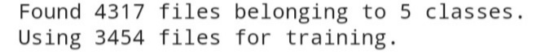

validation_ds **=** tf**.**keras**.**utils**.**image_dataset_from_directory(

data_dir,

validation_split**=**0.2,

subset**=**"validation",

seed**=**107,

image_size**=**(img_height, img_width),

batch_size**=**batch_size

training_ds**.**class_names

Output:



plt**.**figure(figsize**=**(7, 7))

**for** data, labels **in** training_ds**.**take(1):

**for** i **in** range(6):

ax **=** plt**.**subplot(2, 3, i **+** 1)

plt**.**imshow(data[i]**.**numpy()**.**astype("uint8"))

plt**.**title(training_ds**.**class_names[labels[i]])

plt**.**axis("off")

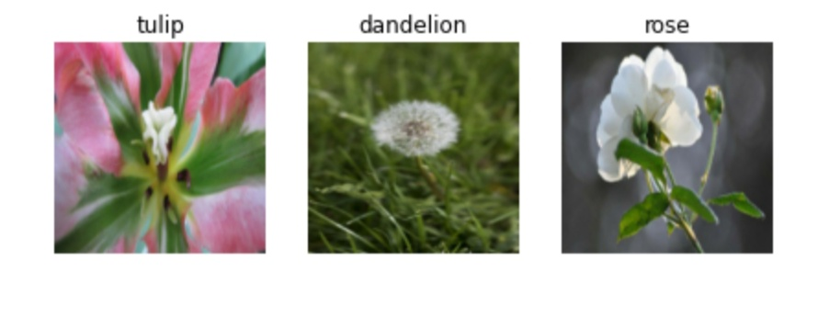

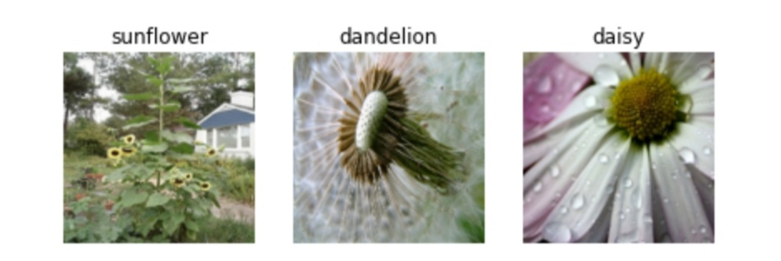

## ****4.Add Layers****

### ****4a. Convolution layer****

Solution:

model**.**add(Convolution2D(32, (3,3), activation **=** "relu", input_shape **=** (64,64,3) ))

### ****4b. Maxpooling layer****

Solution:

model**.**add(MaxPooling2D(pool_size **=** (2,2)))

### ****4c. Flatten****

Solution:

model**.**add(Flatten())

### ****4d. Hidden/dense layers****

Solution:

model**.**add(Dense(300, activation **=** "relu"))

model**.**add(Dense(150, activation **=** "relu"))

### ****4e. Output layer****

### **Solution:**

model**.**add(Dense(5, activation **=** "softmax"))

## ****5. Compiling Model****

Solution:

model**.**compile(optimizer**=**'adam',loss**=**'categorical_crossentropy',metrics**=**['accuracy'])

## ****6. Fit The Model****

Solution:

model**.**fit(x_train, epochs **=** 15, steps_per_epoch **=** len(x_train))

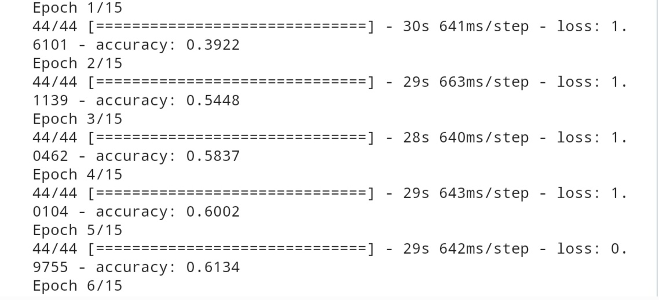

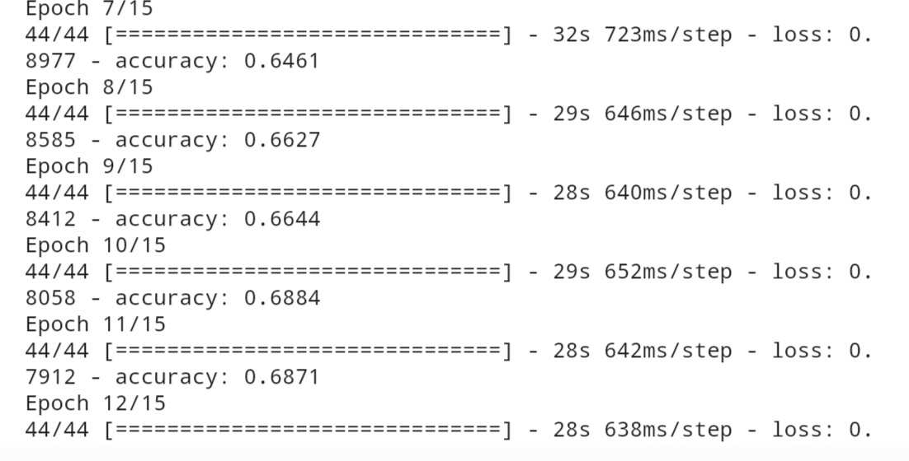

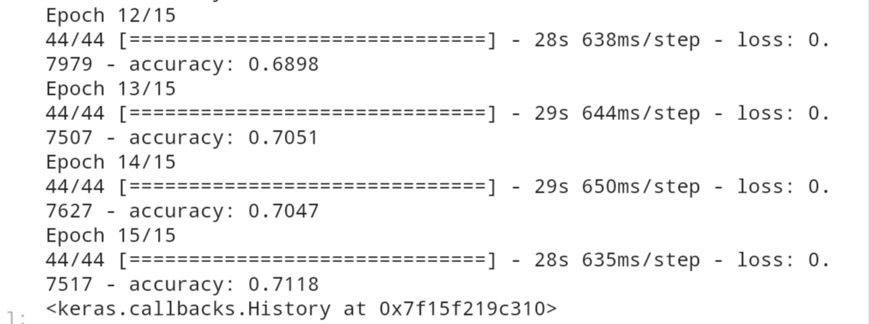

## ****7. Save The Model****

Solution:

model**.**save("flowers.h1")

## ****8. Test The Model****

Solution:

**from** tensorflow.keras.models **import** load_model

**from** tensorflow.keras.preprocessing **import** image

model **=** load_model("/content/flowers.h1")

daisy_img **=** image**.**load_img('/content/flowers/daisy/100080576_f52e8ee070_n.jpg',target_size**=**(64,64))

x **=** image**.**img_to_array(daisy_img)

x **=** np**.**expand_dims(x,axis**=**0)

predicted_class**=**model**.**predict(x)

labels **=** ['daisy','dandelion','roses','sunflowers','tulips']

labels[np**.**argmax(predicted_class)]

Output:



Solution:

daisy_img

Output:

